Online Apparel Shopping

In this project we have developed online Apparel shopping application which consists of following modules

1. Admin: admin can login to system using username and password as ‘admin’. After login admin can add ‘New Apparel details’, view customer orders and can view feedbacks submitted by users
2. User: user can sign up and can login to system. After login user can search apparel by Type, Brand and Style and can add desired item to catalogue, can view list of Cart, can remove items from cart, can perform checkout for payment.
3. As payment we don’t have any gateway so just we are validating credit/debit card numbers given by user, if card no valid then only purchase order will be confirmed.

From your given list of requirements we have completed maximum all possible modules

To run project install python 3.7 and then install MYSQL database and then copy content from DB.txt file and then paste in MYSQL console to create database.

Now double click on ‘run.bat’ file to start python web server and get below page

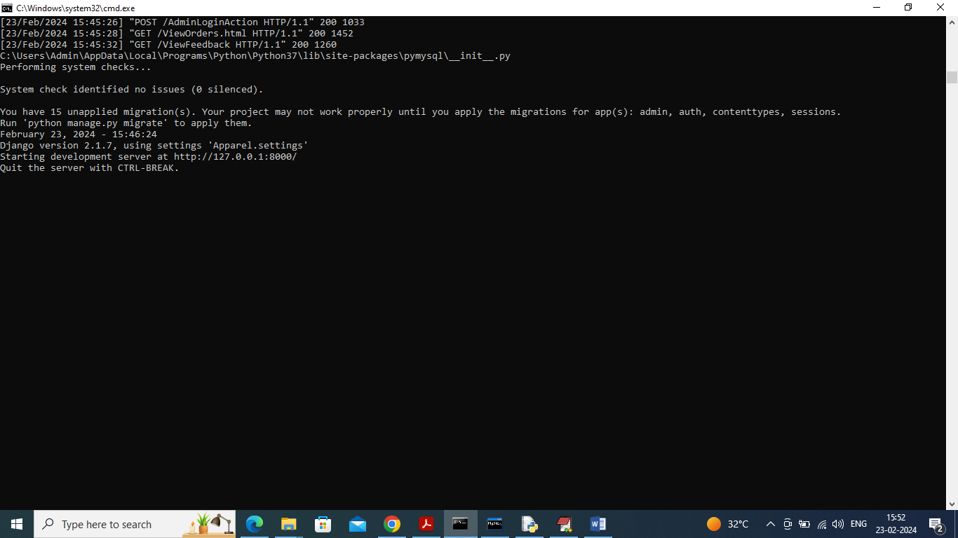

In above screen python server started and now open browser and enter URL as <http://127.0.0.1:8000/index.html> and press enter key to get below page

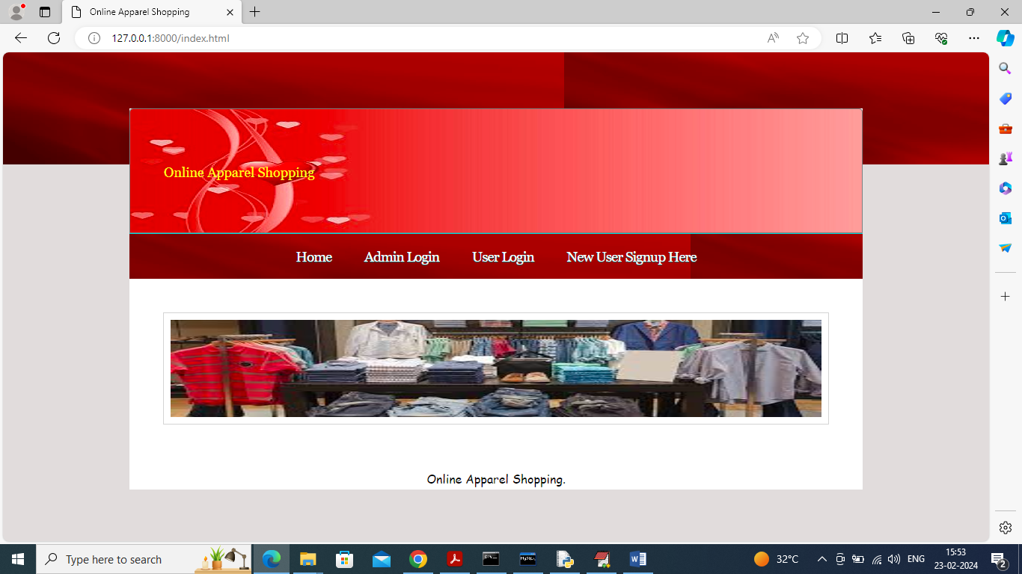

In above screen click on ‘Admin Login’ link to get below page

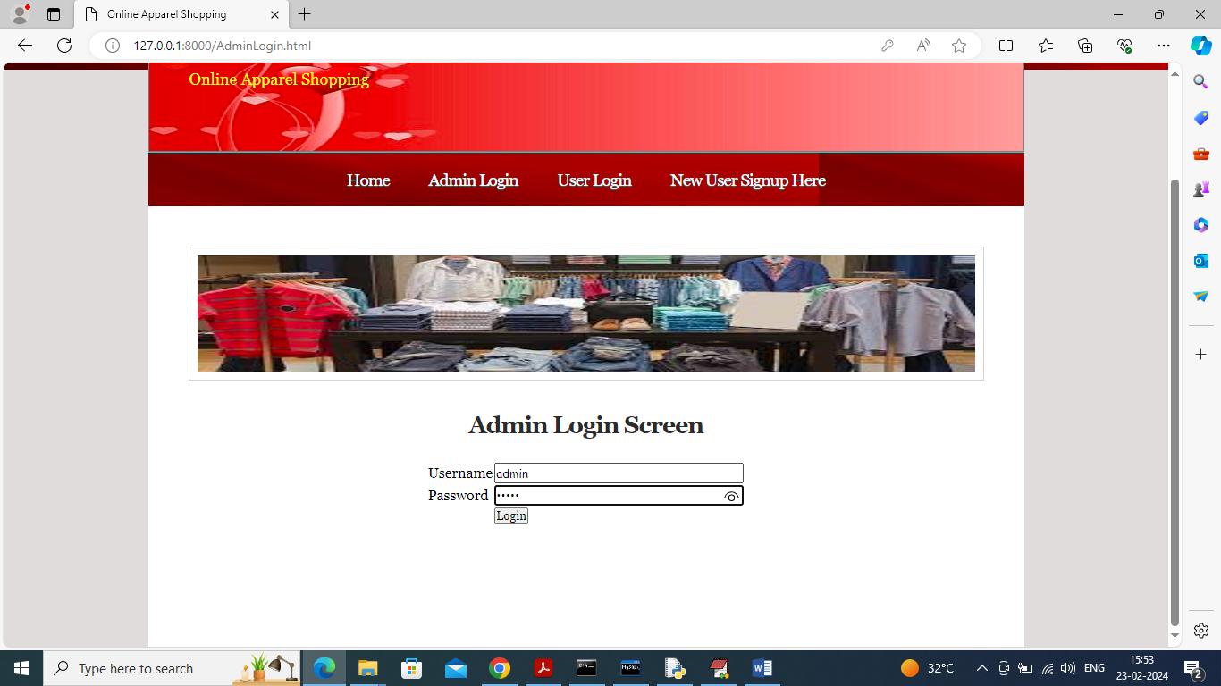

In above screen admin is login and after login will get below page

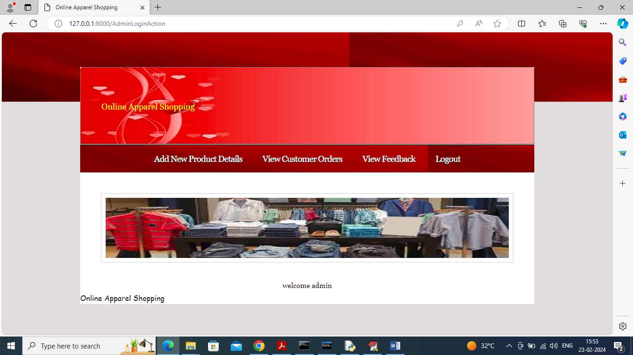

In above screen admin can click on ‘Add New Product Details’ link to add new apparel

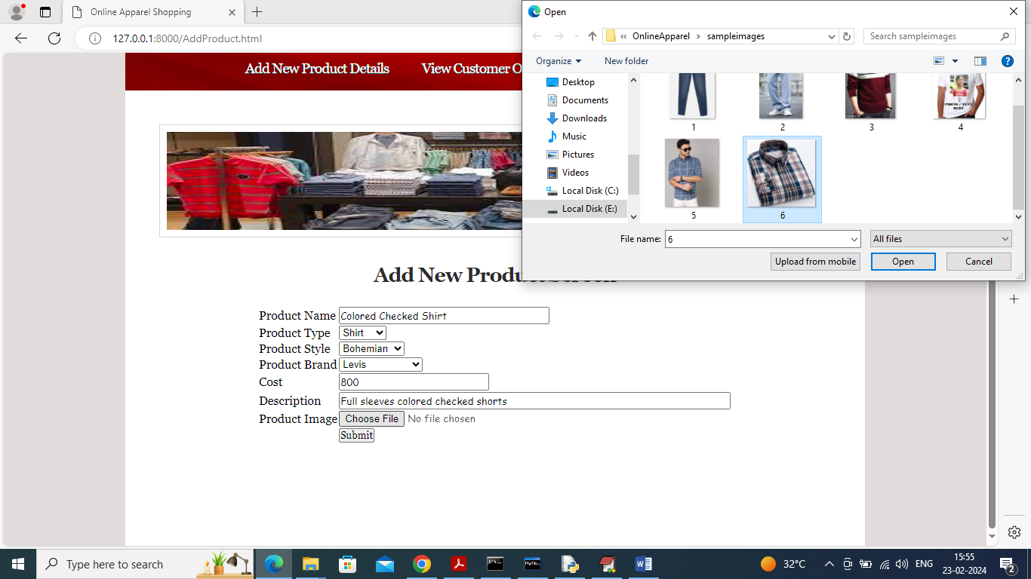

In above screen admin will add all apparel details and then upload related images and then click on ‘Submit’ button to save details and get below page

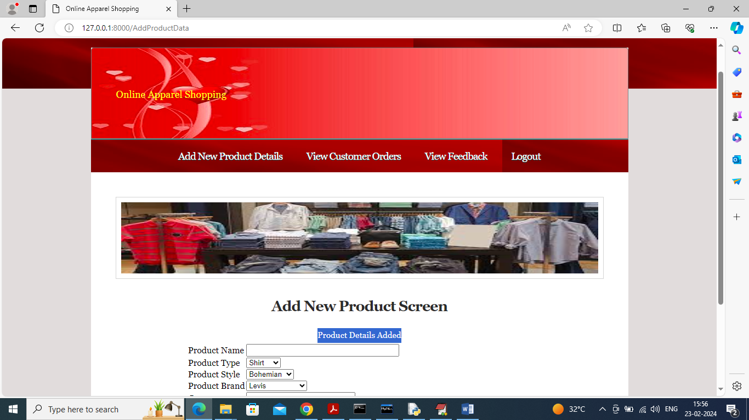

In above screen product details added to database and now logout and login as user to search products

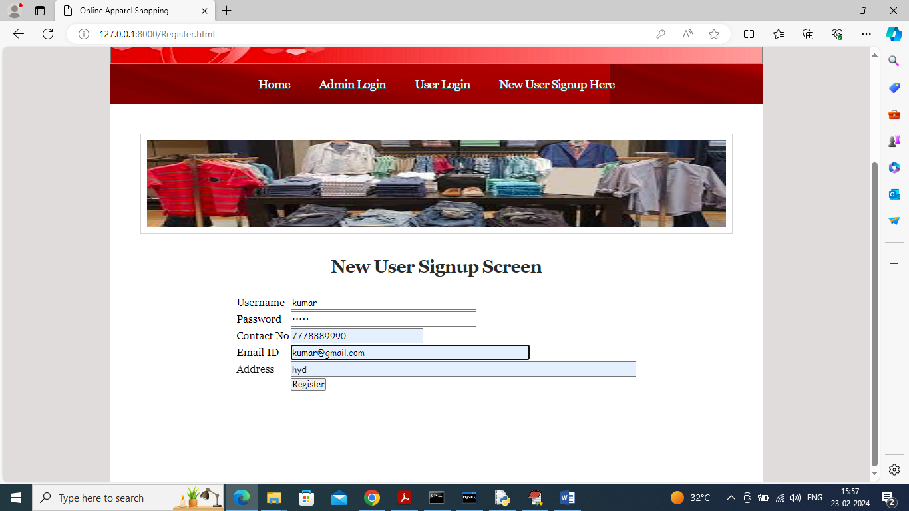

In above screen user is entering sign up details and then press button to get below page

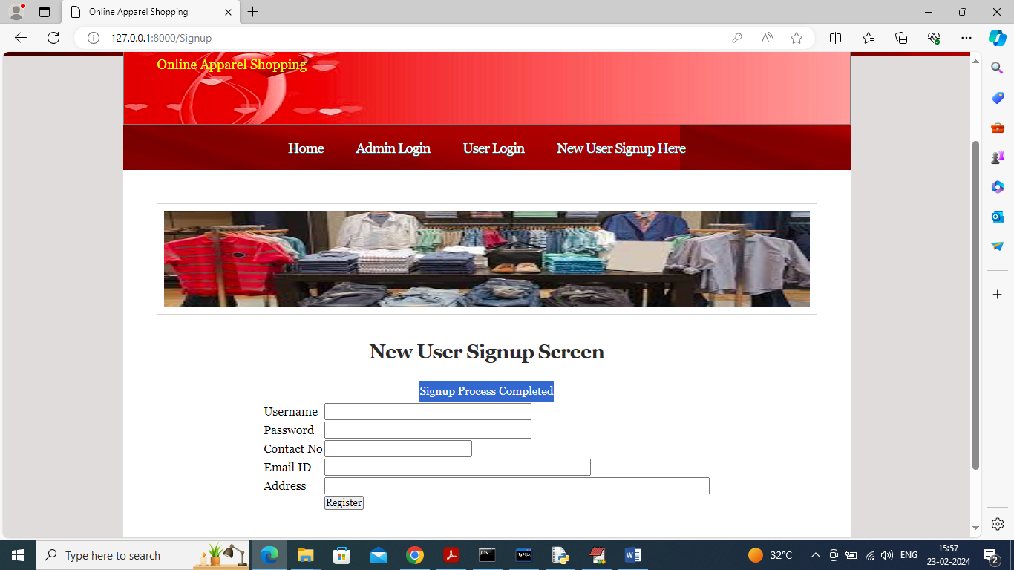

In above screen sign up completed and now click on ‘User Login’ link to get below page

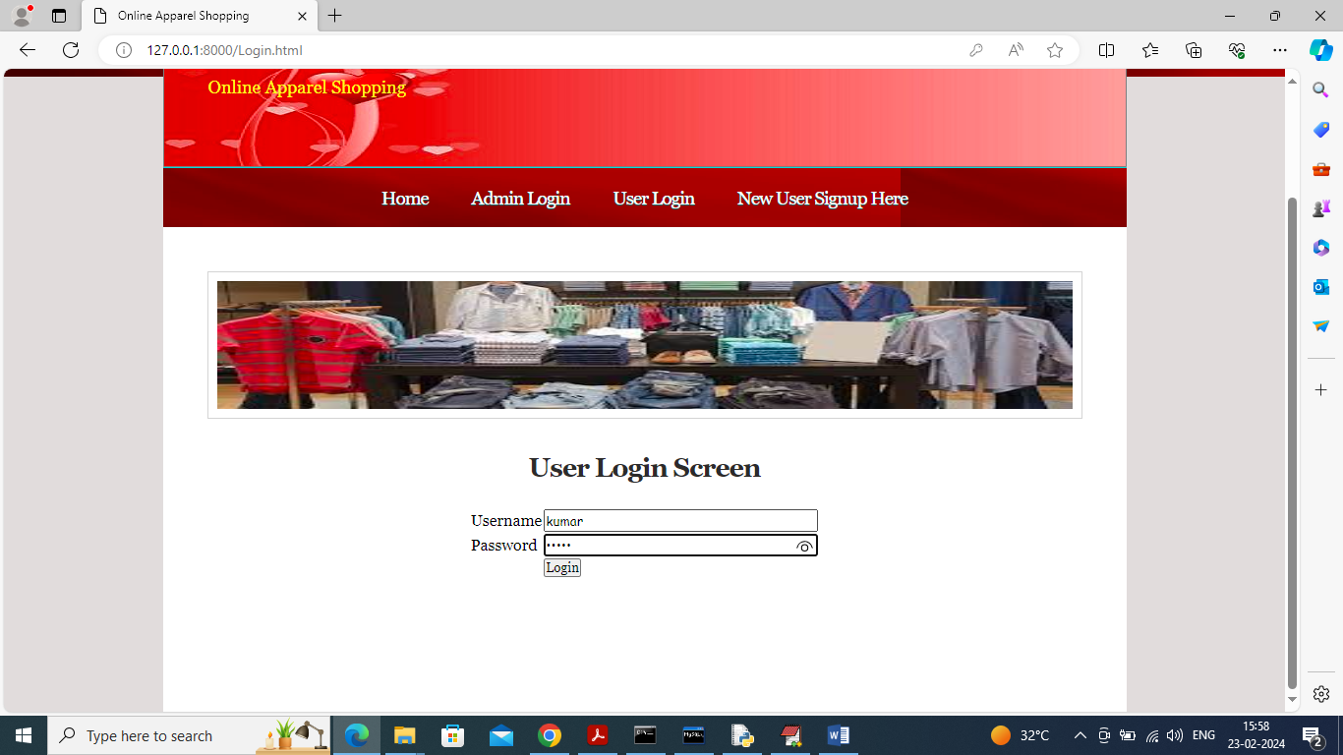

In above screen user is login and after login will get below page

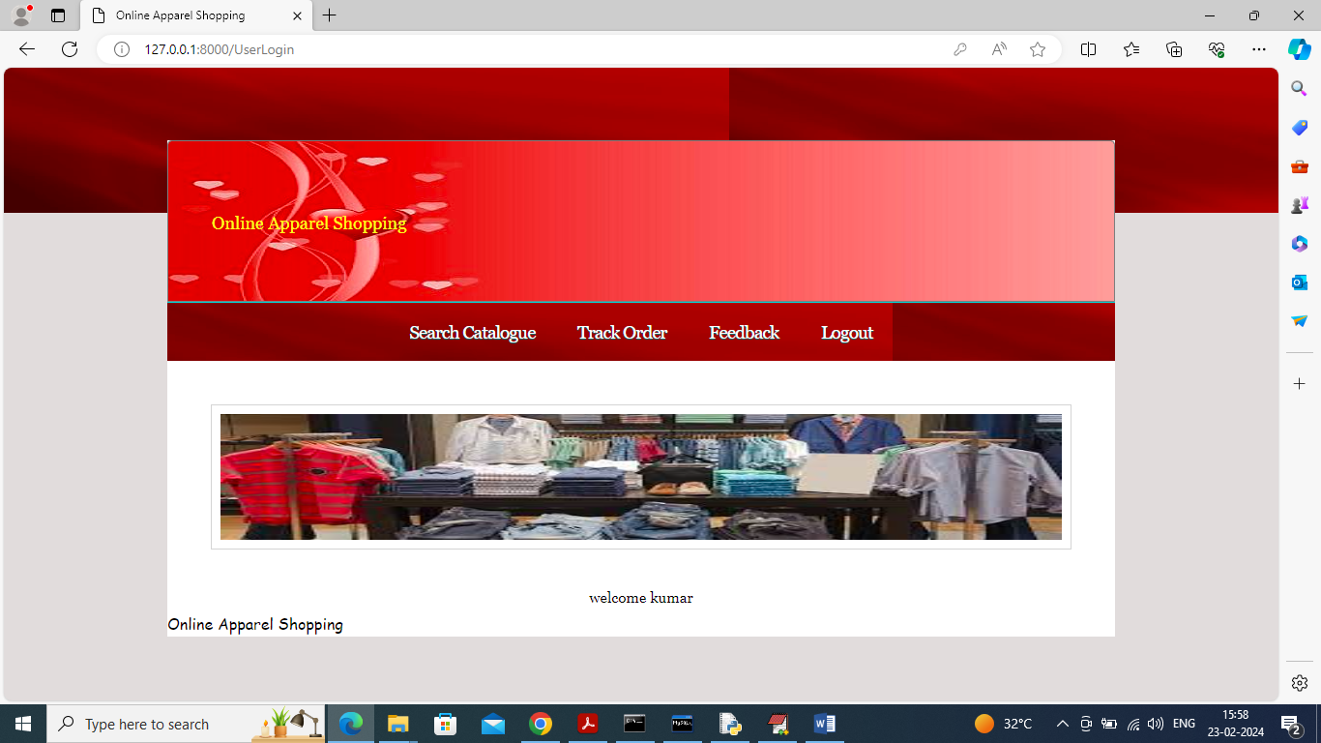

In above screen user can click on ‘Search Catalogue’ link to get below page

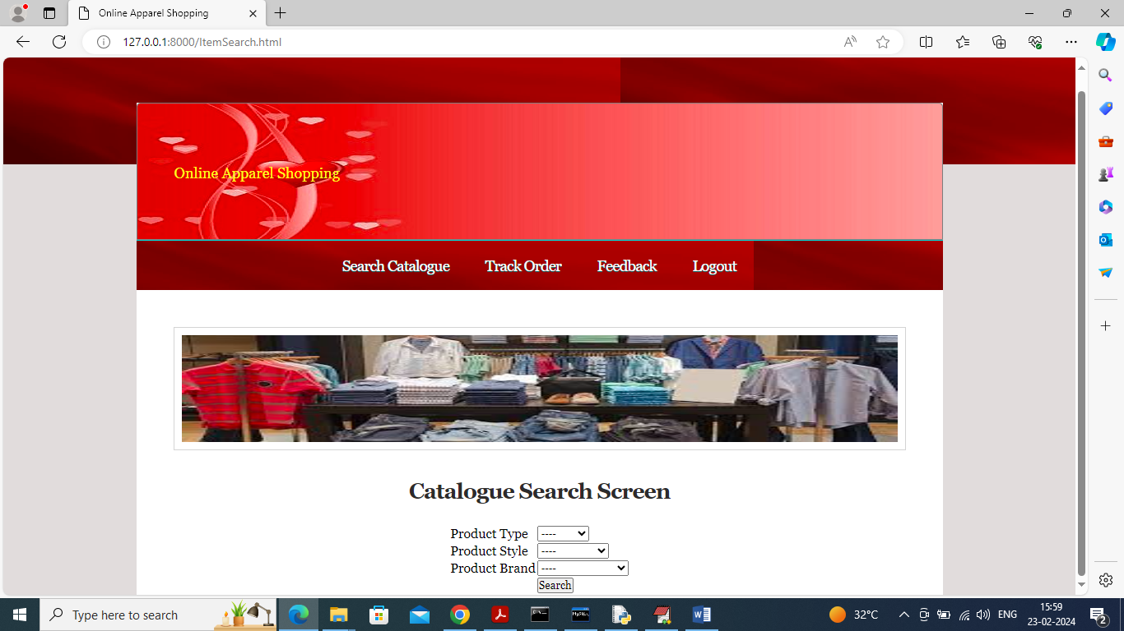

In above screen you can select desired type from all drop down box or anyone to perform search

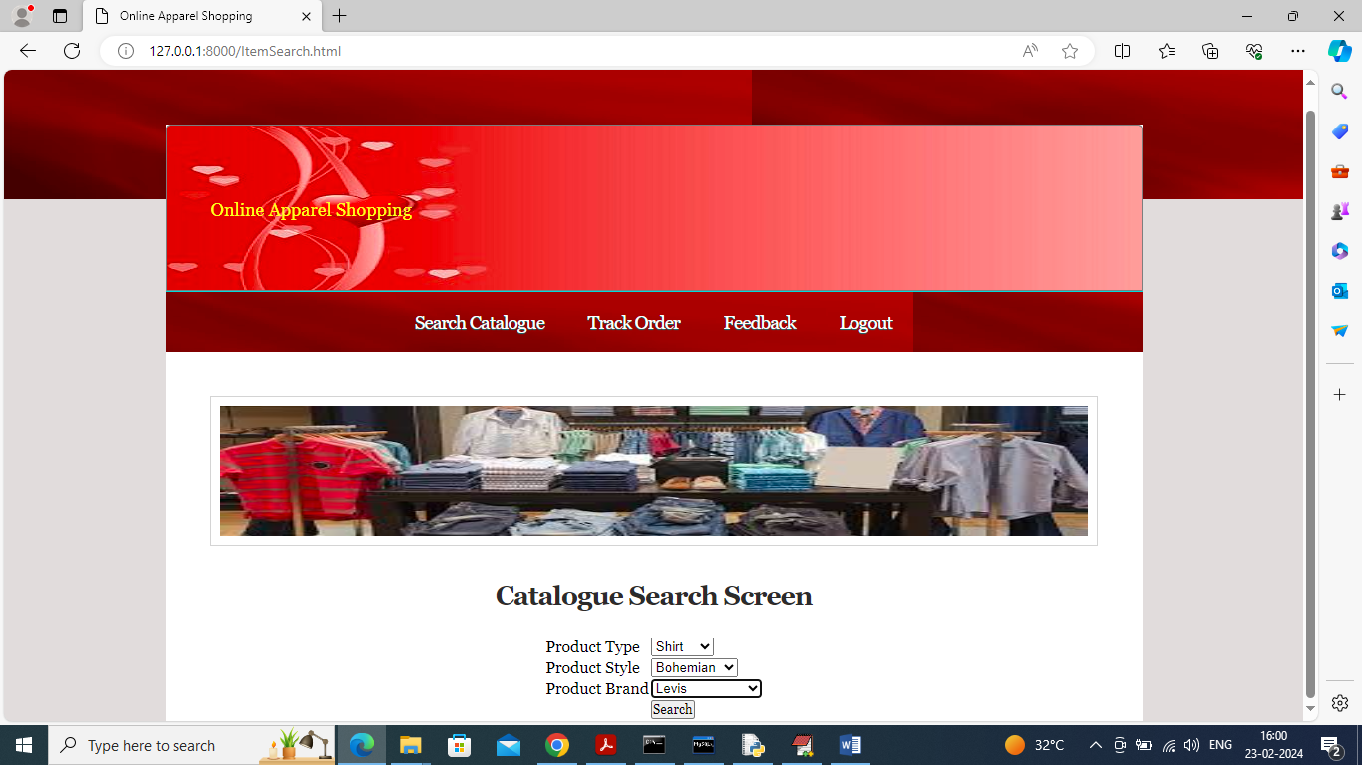

In above screen I make some selection and then press button to get below search list

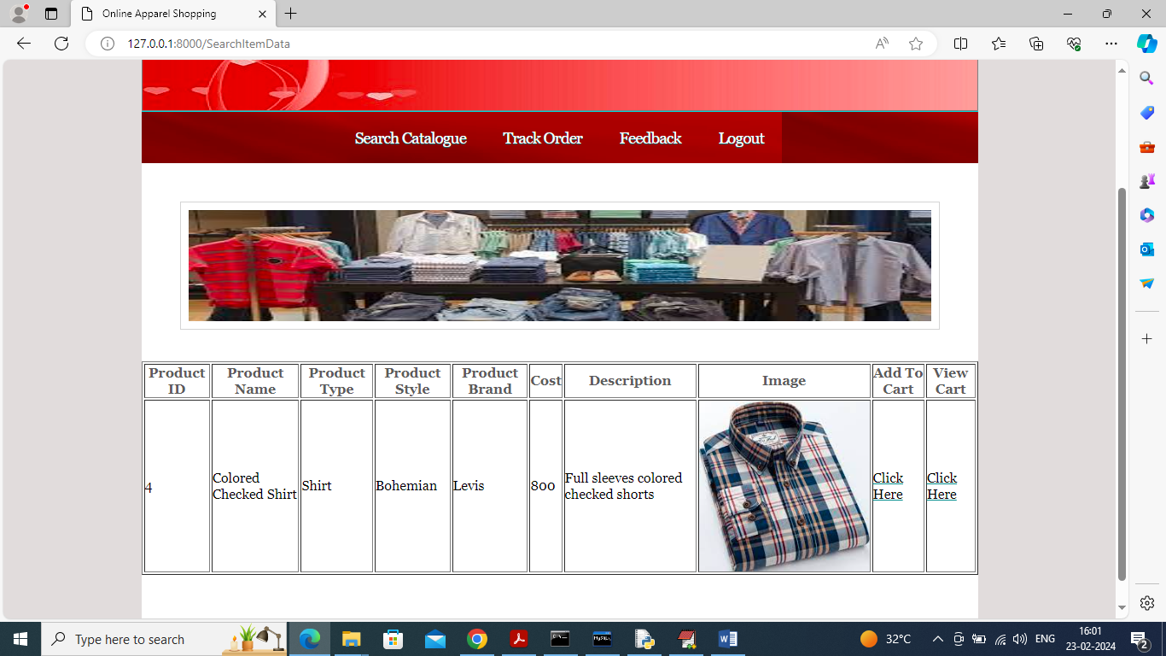

In above screen user can see apparel details with cost and other details and now user can click on ‘Click Here’ under ‘Add to Cart’ link to add items to cart and once added user will be forward to product list and now search other items.

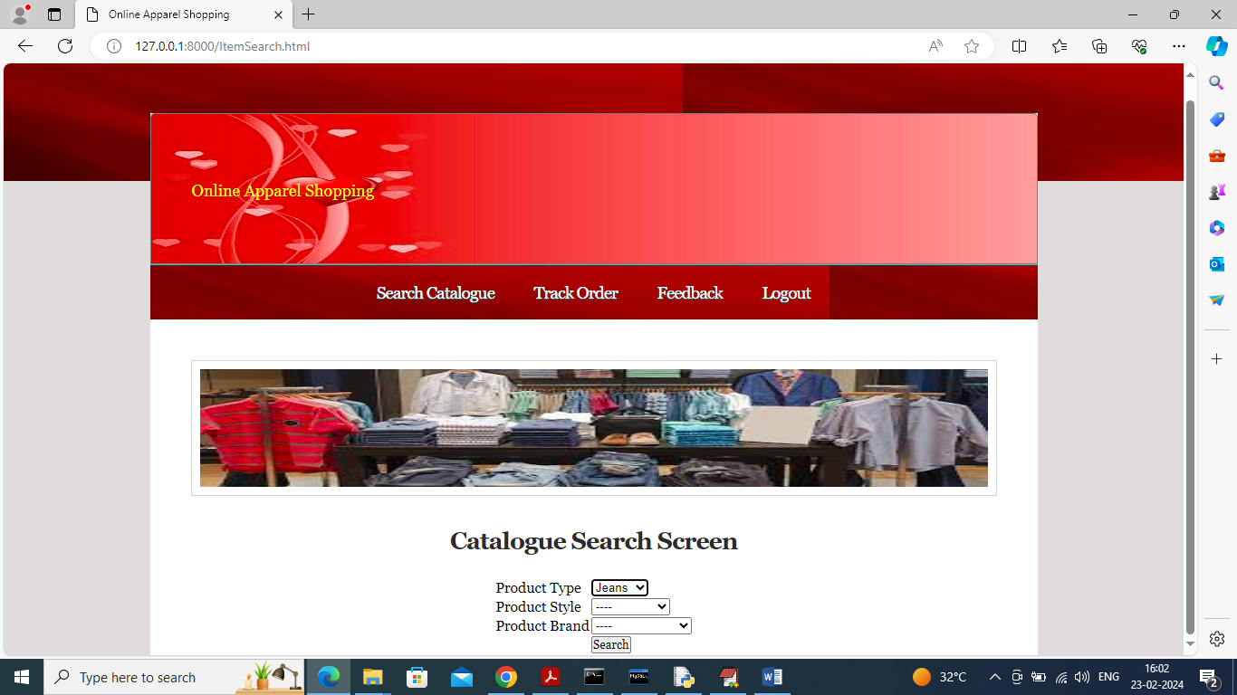

In above screen searching for Jeans and then will get below page

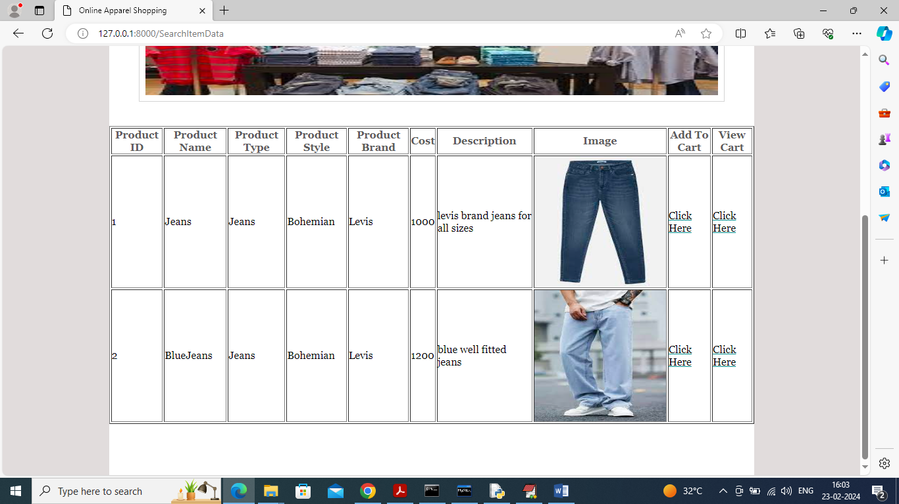

In above screen user can click on ‘Click Here’ link to add items to cart and can click on ‘Click Here’ under ‘View Cart’ link to view cart, remove items and to checkout

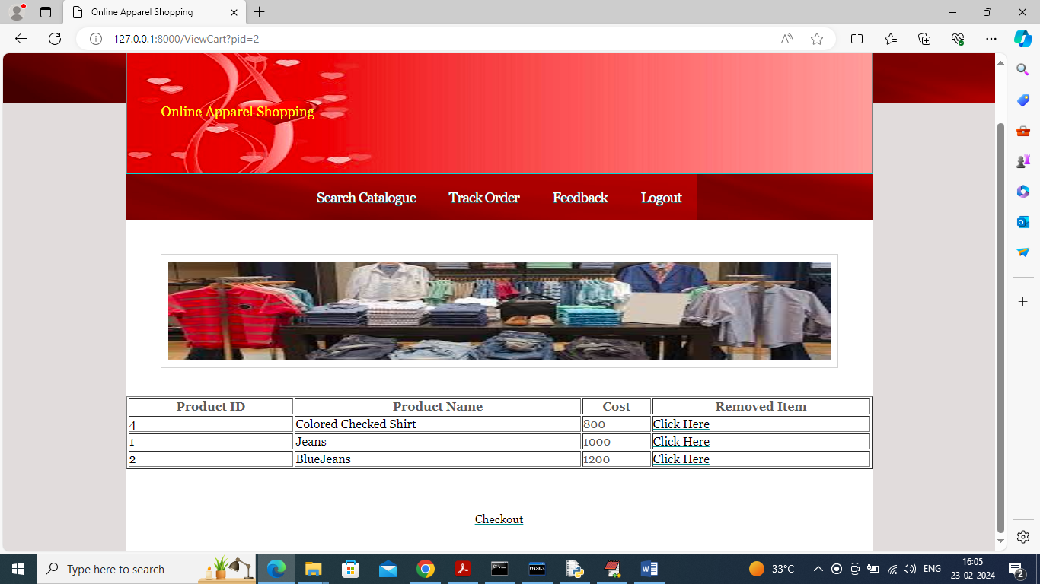

In above screen user can view all products added to cart and can click on ‘Click Here’ link to remove item and then click on ‘View Cart’ link to get below page

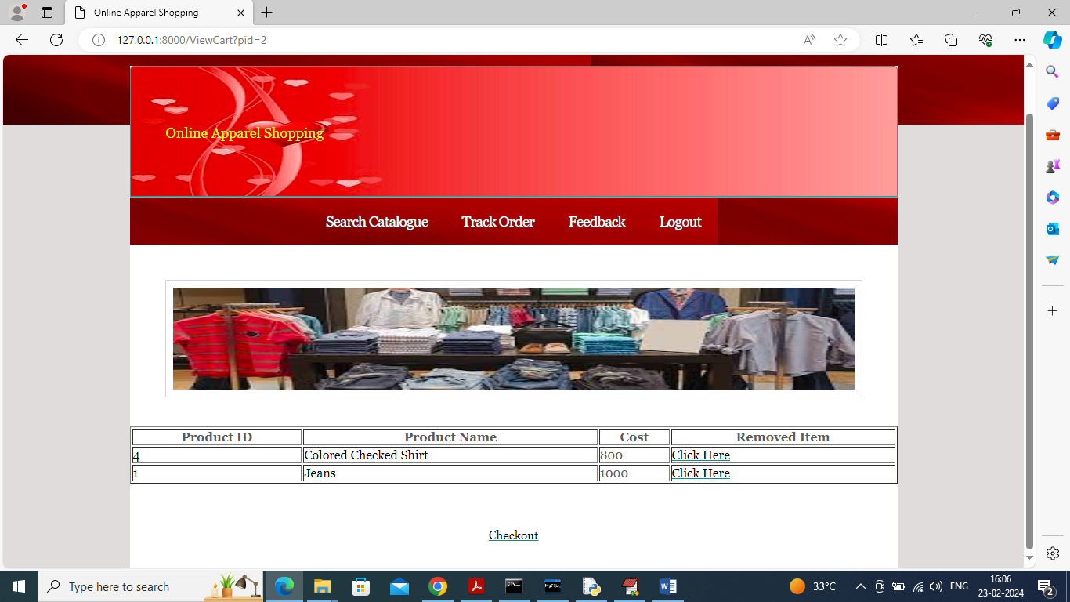

In above screen can see 3rd item removed from the list and can click on ‘Checkout’ link to make payment

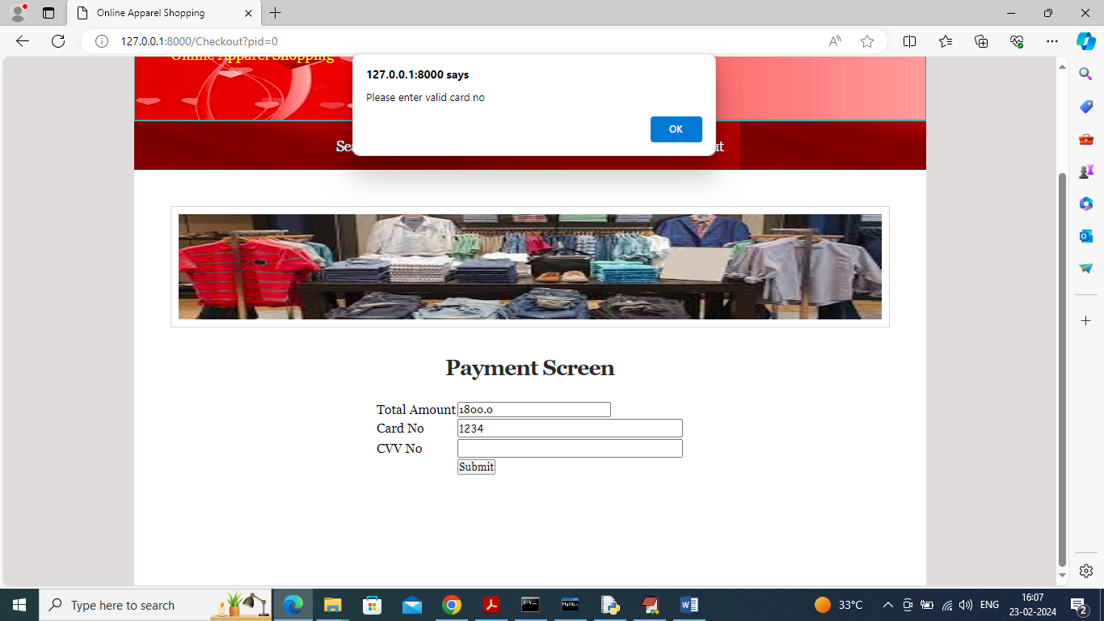

In above payment screen if we give invalid card number then system will throw error so give valid card number like below screen

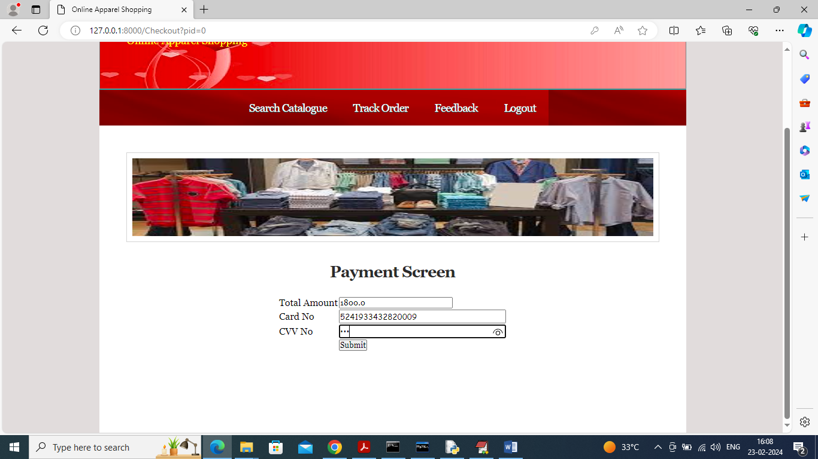

In above screen gave valid card no and then click on ‘Submit’ button to confirmed order and get below page

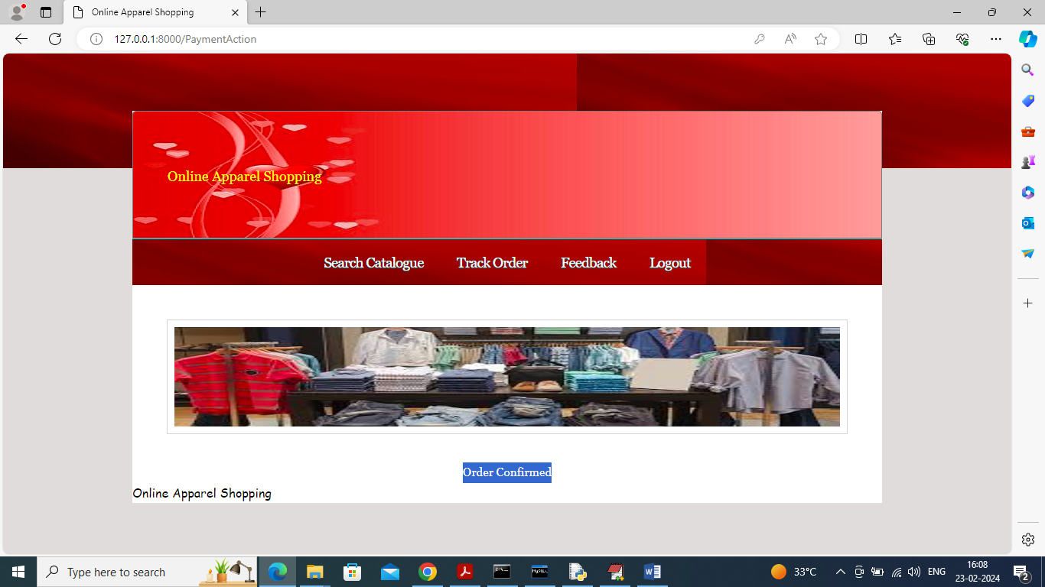

In above screen can see ‘Order Confirmed’ and now user can click on ‘Track Order’ link to view order details

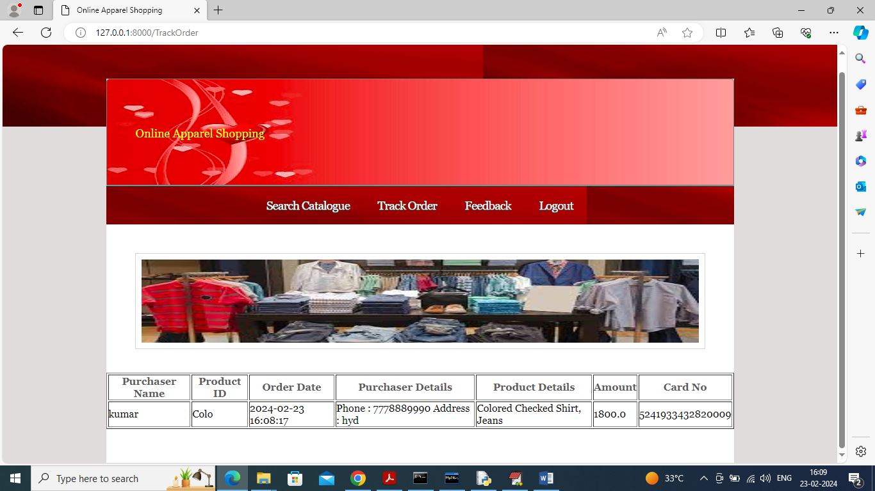

In above screen user can view all order details and now click on ‘Feedback’ link to submit feedback to user

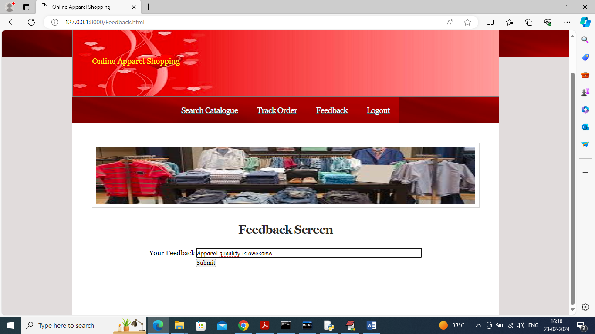

In above screen user can submit desired feedback to admin and now logout and login as admin to view orders

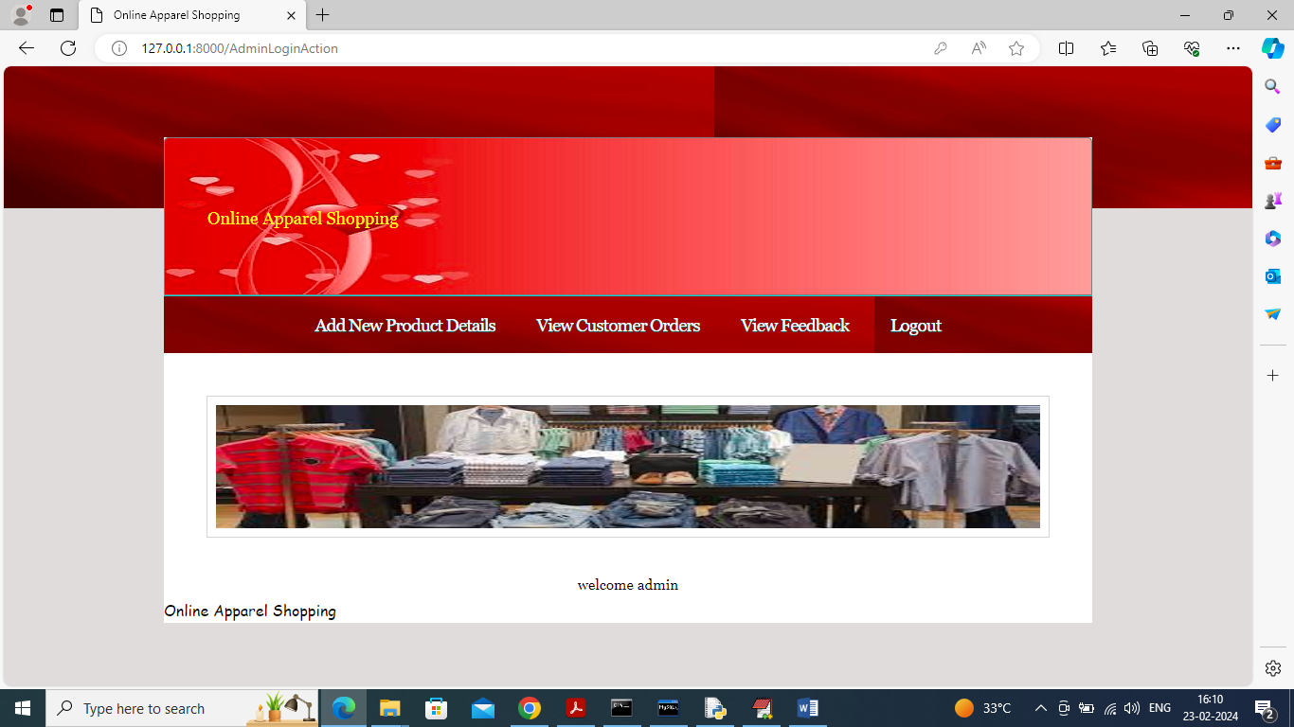

In above screen admin can click on ‘View Customer Orders’ link to get below orders list

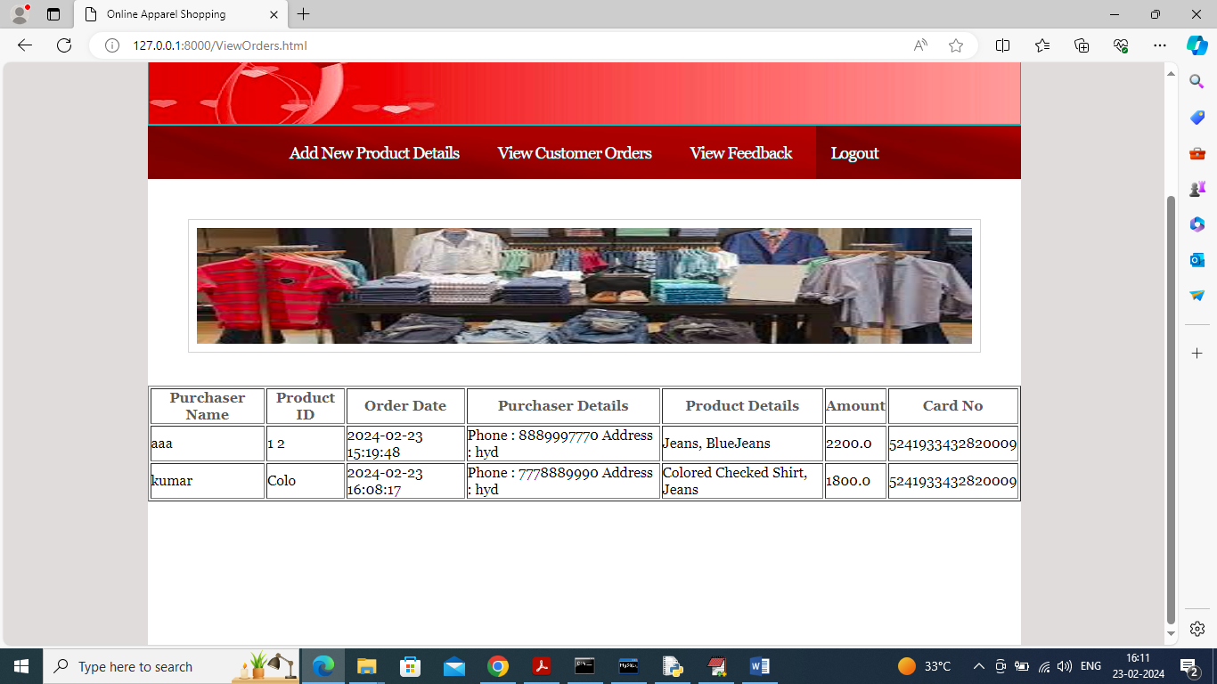

In above screen admin can view all orders from all customers along with address and contact number to ship order and can click on ‘View Feedback’ link to view feedback from users

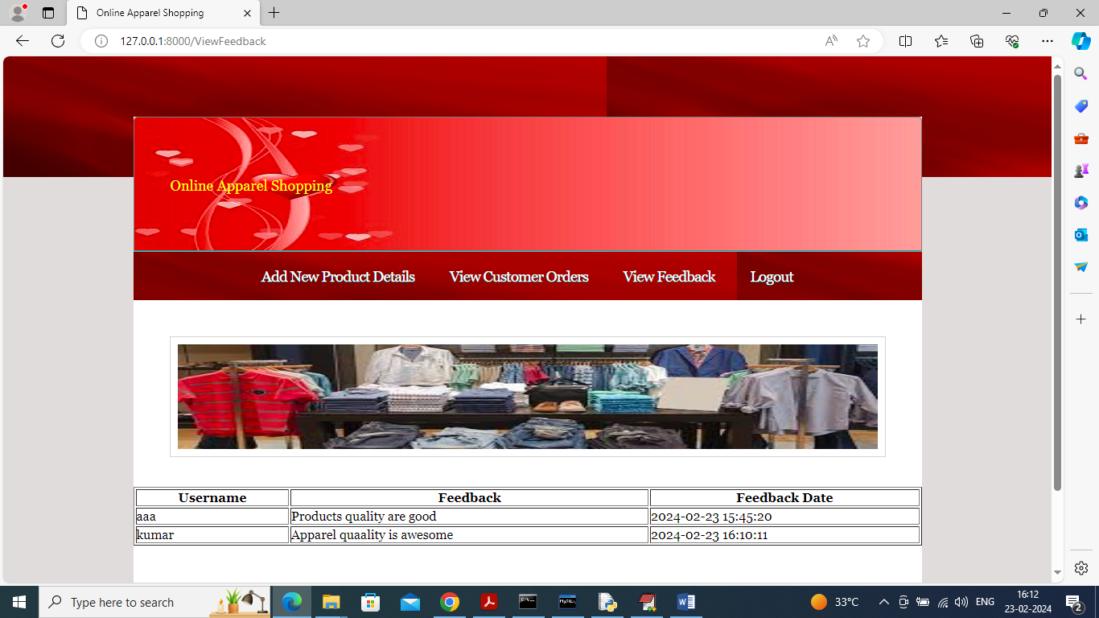

In above screen admin can view all profiles from all users and in below screen you can write own terms and condition

